THE MESSENGER DECEMBER 2024

GILEAD LUTHERAN CHURCH

PO BOX 26 CROPSEYVILLE, NY 12052

CHURCH PHONE: 279-9270

gileadlutheran.org gilead2@verizon.net

Service time 10:30 AM

“I am the Resurrection and the Life,” says Jesus.

Mary and Martha’s brother had died. Had he been there, they said, their brother would not have died. When Jesus arrived in Bethany at the home of the two sisters, they led him to where Lazarus had been buried. Verse 35, known as the shortest verse in scripture, is translated in the New Revised Standard Version as “Jesus began to weep.” It may be more accurately translated as, “Jesus burst out in tears.”

That is where God meets us. In our grief. With us when our world has stopped. With us when those feelings of loss come like a punch in the gut and take our breath away. Jesus meets us here. Jesus loved Lazarus, and when Lazarus had died, even knowing what he was about to do, Jesus burst out in tears.

I was devastated when I heard the news of Jim’s untimely death. He had plans. We had plans together. This is not what was expected. On behalf of the whole church, thank you, God’s people at Gilead, for serving with Jim over these past many years, and especially over the last twelve-months. Jim lived to serve, and loved serving with you.

“I am the resurrection and the life,” says Jesus. Jesus speaks these words to Mary and Martha and to us in the face of death. Knowing the grief of those who loved Lazarus, Christ proclaimed resurrection and life – even on the way to the cross. In this Season of Advent, we wait for God to come again, even as we know that Christ has already come, once and for all. Christ came that Jim, and you, and me, might have life, and have that life abundantly!

I give thanks to Pr. Tom Taylor and his openness to the Spirit and willingness to serve currently. I also give thanks to God for each one of you, for proclaiming the Gospel that because Christ lives, we shall also live and declare the wonders of God.

Yours in Christ,

Bishop Lee M. Miller II

**GILEAD’S VISION STATEMENT**

We ring out a joyous message of welcome and togetherness to neighbors near and far through the Spirit of Christ!

**VALUES FOR GILEAD LUTHERAN CHURCH**

PRAISING GOD through Traditional and Contemporary music and Lutheran liturgy.

GROWING IN FAITH through Fellowship, Study, Prayer and Service.

STAYING CONNECTED with each other and reaching out to others in the community.

LISTENING for the Spirit’s guidance in all we do.

AFFIRMING each person as worthy of love and respect.

Please keep our homebound and those that can’t be with us in your prayers:

John Grassman, Mike Boomhower, Matthew Raymond, Bob Guerin, June Boomhower, Rick Brown, Elaine Frank, Marcy Mulner, David Sweet, Lilian LaBarge, Flora lee Ashdown, Bonnie Erickson. Tom Martin, Jenifer Mann, Leonard Flath, Joy Alber, Laura Vadnais, Mark Kelsey Harold Behrens.

**DECEMBER BIRTHDAYS**

Joseph Danner 2 Allen Sheffer 25

Robin Jones 13 Eleanor Bode 27

Gerald Flynn 23 Pastor Houlihan 28

Jack Rifenburg 25 Bradlee Bugbee 29

**DECEMBER ANNIVERSARIES**

Keith and Lisa Kreiger 16

Robert and Regina Button 28

Jon and Cindy Price 31

DECEMBER CHURCH CALENDAR

**1st Sunday of Advent, Dec 1st 4th Sunday of Advent, Dec 22nd**

Holy Communion Holy Communion

1st Reading: Jeremiah 33:14-16 1st Reading: Malachi 5:2-5a

Psalm: 25:1-10 Psalmody: Luke 1:46b-55

2nd Reading: 1Thessalonians 3:9-13 2nd Reading: Hebrews 10:5-10

Gospel: Luke 21:25-36 Gospel: Luke 1:39-45

**2nd Sunday of Advent, Dec 8th Christmas Eve. Dec 24th**

Holy Communion Holy Communion

1st Reading: Malachi 3:1-4 1st Reading: TBD

Psalmody: Luke 1:68-79 Psalm: TBD

2nd Reading: Philippians 1:3-11 2nd Reading: TBD

Gospel: Luke 3:1-6 Gospel: TBD

**3rd Sunday of Advent, Dec 15th 1st Sunday of Christmas Dec 29th**

Holy Communion Holy Communion

1st Reading: Zephaniah 3:14-20 1st Reading: 1 Samuel 2:18-20, 26

Psalmody: Isaiah 12:2-6 Psalm: 148

2nd Reading: Philippians 4:4-7 2nd Reading: Colossians 3:12-17

Gospel: Luke 3:7-18 Gospel: Luke 2:41-52

**WORSHIP LEADERS**

December 1st Sam Janice Walz

December 8th Pastor Judy Converse

December 15th Pastor Judy Converse

December 22nd Pastor Tomas Taylor

December 24th Pastor Tomas Taylor

December 29th Pastor Tomas Taylor

**EVENTS CALENDAR**

December 10th Council Meeting 5:30pm

December 24th Service TBD

**Gilead Family**

We have had such a crushing blow with the death of our brother Jim Netzer. We thought he was improving and was trying to figure out a way to do physical therapy and still be able to serve as our worship leader. He was an asset to any church he served. People at Prince of Prince in Lansingburgh thought a lot of him. We at Gilead have had the pleasure of sharing his love of God. When working on his contract he wanted less financially. His line was always I can do with less. Jim’s sudden death has left us trying to carry out his programs and continue having a morning worship service. There has been a statement What Would Jesus Do. Trying to keep a normal Sunday service each week, we find that line to be What Would Jim Netzer Do? We miss so many of our young members. We would appreciate your help; no, we are not saying your money. We need your input on what needs to be done so Gilead will be somewhere you and your children will be proud to call this old congregation, to help us keep the 1744 congregation alive. Our founder fathers would be proud to know their dream is still alive. Please, Please, Please allow us to right any wrongs we have done. We need new ideas and input from our younger members.

**Christmas Memorials 2024**

The following information has been announced in church for a few Sundays. So, we can keep the rest of the congregation in the loop we are publishing the cost of the Poinsettias for Christmas 2023.

Six-inch pots will be $ 11.00 and Nine-inch pots will be $ 22.00; the Poinsettias will be included. All orders must be in by Sunday December 15th for them to be listed in the Christmas Eve Bulletin.

Because we are not having a Christmas Eve morning service, flowers will be placed in the Chancel for the December 22nd Service.

The sign-up sheet is on the table at the back of the Sanctuary. Usually if you have questions about the flowers, we ask you to contact the Shanahan’s by phone. This year your questions should be sent to: jmike50@aol.com .

**A Message from The Cookie Monster**

The cookies slated to be to us by December 15th have been changed. We now need the cookies by December 22nd.

Sorry for the confusion.

**2024 Advent devotional**

"Luther Seminary invites you to use the 2024 Advent devotional, "Joy of Heaven, Here on Earth" for personal or congregational use this Advent."  As a God Pause subscriber, you will receive this devotional in your email inbox each day of Advent.  There is no charge for the devotional.  Go to www.luthersem.edu/godpause/

**Thanksgiving Baskets**

We had 14 families who received baskets this year. We thank Fane’s Industries for their donation of Turkeys. Delsignore’s also donated items for the dinner. One of our members helped Lisa with the rest of the shopping and refused to accept any money for her items.

Finally, Darlene, Tanis, and Eleanor made pumpkin and apple pies for dessert. With all those pies you need helpers. One of our younger helpers, Owen Kreiger, decided he would make pie crusts. He measured the ingredients and even cut the

Crisco into the flour.

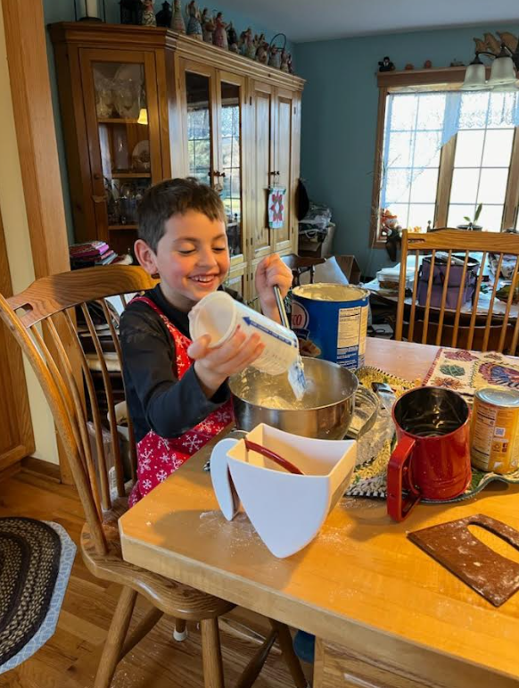

**Sunday School News**

Thank you to everyone who came out for our Halloween Party at the end of October! The kids had a great time playing games, making crafts, and having their faces painted. Also, a huge thank you to everyone who planned and joined in the Trunk or Treat. Everyone was thrilled with the buckets full of goodies they brought home and all the great decorations you all came up with!  
  
Our important dates for December:  
  
Sunday 12/8- Sunday School meets during worship. We will be rehearsing for our Christmas pageant.  
  
Sunday 12/15- Our Christmas Pageant: Molly and Millie’s Christmas Manger! Please join us to support the children who have worked so hard. We will be performing during worship in lieu of a Children's Message.12/10 - Sunday School meets

12/17 - Christmas Play - "The New Star"

1/14 - Sunday School meets

|  |  |
| --- | --- |
|  |  |

# 

# White Chocolate Peppermint Cookies

* 1 cup (2 sticks) unsalted butter softened
* 1 cup vegetable or canola oil
* 1 cup granulated sugar
* 1 cup confectioners' sugar
* 2 tsp vanilla extract
* 1 tsp peppermint extract
* 2 large eggs
* 1 tsp baking soda
* 1 tsp cream of tarter
* 1 tsp salt
* 4 cups + 2 Tbsp all-purpose flour
* 1½ cups Andes peppermint chips
* 1 cup white chocolate chips
* 2 Tbsp heavy cream
* 2/3 cup crushed candy cane pieces
* In the bowl of a stand mixer, cream the butter until fluffy, about 1 minute. Slowly beat in the oil, sugars, and extracts until combined. Beat in the eggs, one at a time, mixing well after each addition. Gradually add in the dry ingredients and mix on low-speed until incorporated, scraping the sides of the bowl as needed. Beat in the peppermint chips until combined. Cover loosely with foil or plastic wrap and chill for 2 hours. Chilling is MANDATORY.
* Preheat oven to 350 degrees F. Line 2 baking sheets with silicone liners or parchment paper. Drop rounded Tablespoonfuls of dough onto the baking sheets about 1-2" apart. Bake for approximately 9-11 minutes, rotating pans halfway through the baking time to ensure even cooking. Cool completely on the baking sheets.
* Once cookies are cooled, melt the white chocolate chips and heavy cream together in a small bowl for 30 seconds in the microwave. Stir, then heat for another 10 seconds until melted and smooth. Drizzle evenly over the cookies and immediately top with crushed candy cane sprinkles.

**November 2024 Messager Puzzle Answers** 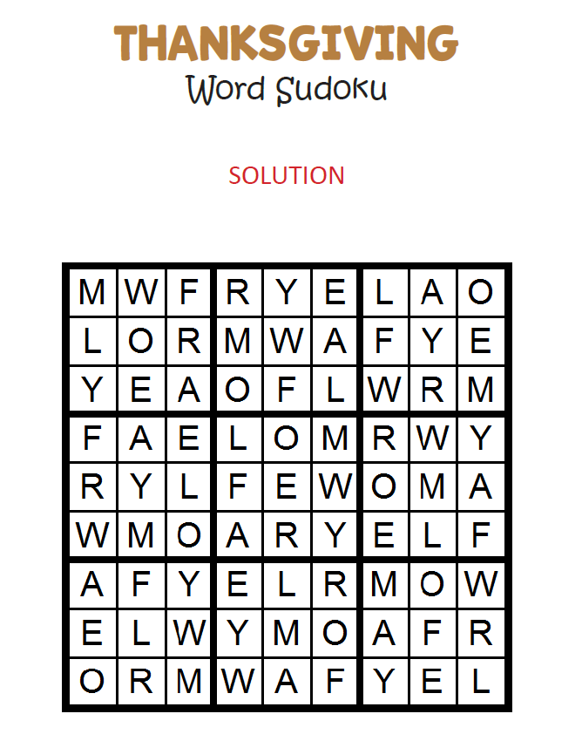

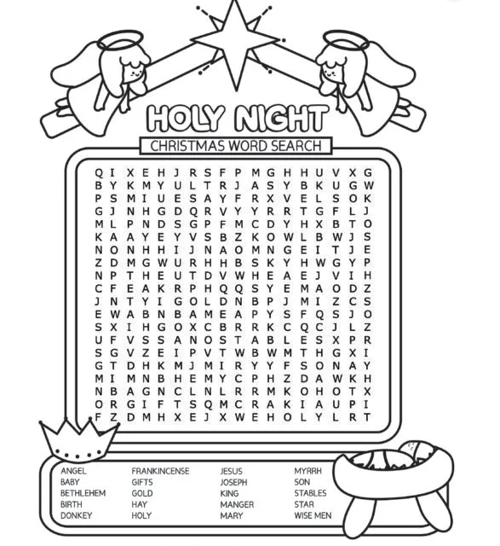

|  |  |
| --- | --- |
| December | 2024 |

|  |  |  |  |  |  |  |
| --- | --- | --- | --- | --- | --- | --- |
| Sunday | Monday | Tuesday | Wednesday | Thursday | Friday | Saturday |
| 1 | 2 | 3 | 4 | 5 | 6 | 7 |
|  |  |  |  |  |  |  |
| 8 | 9 | 10 | 11 | 12 | 13 | 14 |
|  |  | Council Meeting  5:30pm |  |  |  |  |
| 15 | 16 | 17 | 18 | 19 | 20 | 21 |
|  |  |  |  |  |  |  |
| 22 | 23 | 24 | 25 | 26 | 27 | 28 |
|  |  | Christmas Eve Service  TBD |  |  |  |  |
| 29 | 30 | 31 | 1 | 2 | 3 | 4 |
|  |  |  |  |  |  |  |

**GILEAD LUTHERAN CHURCH**

**PO BOX 26**

**CROPSEYVILLE, NY 12052**

December 2024

**READ ME, SEE WHAT’S NEW!!**

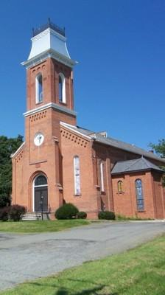



**Gilead Lutheran Church**

**Brunswick, New York**

**Founded 1742**